Corona Virus (Covid19) Bulletin | - March 25, 2020  - •  - Sumas First Nation
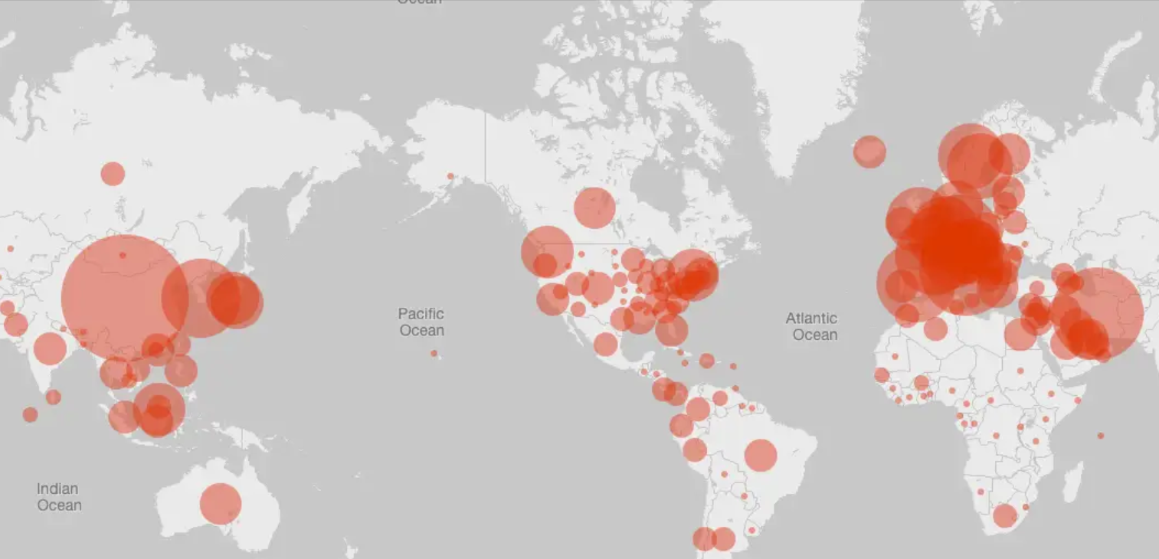  Advisory: Please stay home &  Do not go out unless essential  In recent weeks, we've seen the effects of COVID-19 — but we've also seen the best of each other. Ts’itóle tset, thank you to everyone for doing their part to get us through this difficult time.    As we work with all of our members to address their pressing concerns, our hope is that we're able to make the short term better, while we continue to plan together for the future of S’olh Temexw.  We’re working hard to meet the needs of our community by keeping the band office staffed, increasing public awareness and understanding, and improving community supports.  Community Work  Food Parcels: dry goods, fresh produce, meat, and household items delivered March 20th  Band Office Open: front doors will be locked as precaution, please call on arrival  Daily Check In With Vulnerable Members: staff are communicating with Elders and at-risk members daily to ensure their safety  **Further food assistance and supports to come**  **All community events cancelled until further notice**  Background Info  COVID-19 is a new disease that has not been previously identified in humans.  Consult your health care provider ASAP if:  You display symptoms and/or  You traveled to a high-risk region  Prevention  ➊ Practice vigilant hand washing  ➋ Avoid touching your face  ➌ Work from home if possible  ➍ Comply with travel advisories & self-isolation  ➎ Maintain social distancing of six feet  Symptoms  Fever, Cough, Difficulty Breathing & Pneumonia  If you are ill and must visit a health care professional, call ahead or arrange a phone/video consult.  Diagnosis  Coronavirus infections are diagnosed by a health care provider based on symptoms and lab tests.  Treatment (flu vaccine will not protect you)  There is no vaccine or natural health products authorized for COVID-19 treatment.  Most people with mild coronavirus illness will recover on their own. Your health care provider may recommend steps you can take for symptom relief.  Please get your news from:  - The BC Centre for Disease Control  - First Nations Health Authority  - Fraser Health    - The Government of Canada  - The Government of BC  - Assembly of First Nations  - SFN Social Media & Website |   We’re here for you in challenging times  Key Info  - For assessment and supports:  www.abbotsfordcovidresponse.com  - Use Phone/Online Consult at Your Doctor and Pharmacist  - Senior/vulnerable people store hours 8am- 9am at Saveon, Superstore No Frills, and Shoppers  BAND SERVICES  Health & Admin Buildings:  Call Reception @ 604-852-4041  Monday- Friday 8am – 4pm  Members-Only by Appointment  Smoke Shop:  Last Day Open March 26th 1-3pm  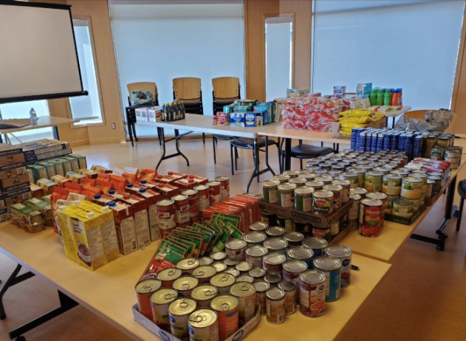  March 19: Some of the SFN food parcel items  OUR COMMITTMENT  We commit to standing by you in these very complicated times.  We're going to play our part.  Please do your best to take care of yourself and each other.  Staff Contacts  Emergency Plan Team, Leadership & Management  Clint Tuttle, Council Rep 604-751-0967  Clnt.tuttle@sumasfirstnation.com  Murrary Ned, Councillor 604-309-7824  Chris Silver, Councillor 778-347-3707  Dalton Silver, Chief 604-751-0947  Wendy Phair, General Manager 778-347-3705  Wendy.phair@sumasfirstnation.com  Jackie Bird, Health/Wellness Manager 604-751-0961 Jackie.bird@sumasfirstnation.com  Craig Hougen, Director SXDL 604-226-9669  Craig.hougen@sumasfirstnation.com  Lori Kelly, Executive Assistant 778-908-9092  Lori.kelly@sumasfirstnation.com  Joe Silver, Public Works 604-751-0954  Joe.silver@sumasfirstnation.com  Emily Slater, Communications Officer 672-998-3056 Emily.slater@sumasfirstnation.com  Jonathan Swanson, Governance 778-808-9250  Jonathan.swanson@sumasfirstnation.com  Geshia Flores, DC/PS Manager 778-246-5245  Geshia.flores@sumasfirstnation.com  Call Line Outreach  Josie Kelly, Lands Officer 604-309-8184  Josie.kelly@sumasfirstnation.com  Malonie Langthorne, Emplym’t & Train’g 604-807-1222  Maonie.longthorne@sumasfirstnation.com  Jennette Pierre, EDO SXDL  Jennette.pierre@sumasfirstnation.com  Lyndy Silver, Executive Assistant  Lyndy.silver@sumasfirstnation.com  Food Security  Amber Ned, Education Coordinator 778-918-2840 Amber.ned@sumasfirstnation.com  Alana James, Events Coordinator 604-226-1582 Alana.james@sumasfirstnation.com  Barb Kelly, Youth Worker 604-226-6051  Barb.kelly@sumasfirstnation.com

