Corona Virus (Covid19) flyer | - March 19, 2020  - •  - Sumas First Nation
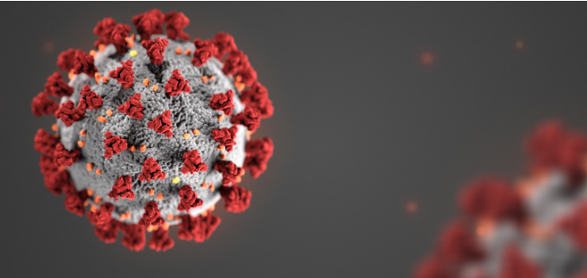  Let’s prevent the spread and encourage community safety  First and foremost, we want you all to know that we are here to help. We will be maintaining member-only access and support at the band office.  Background Info  COVID-19 is a new disease that has not been previously identified in humans.  Consult your health care provider as soon as possible if:  you are concerned about your symptoms or    you have a travel history to a region where coronaviruses are severe.  Prevention  ➊ Practice vigilant hand washing  ➋ Avoid touching your face  ➌ Work from home if possible  ➍ Comply with travel advisories, and self-isolation as needed  ➎ Maintain social distancing of six feet  Symptoms  - Fever  - Cough  - Difficulty breathing  - Pneumonia in both lungs  If you are ill and must visit a health care professional, call ahead or arrange a phone/video consult.  If you have travelled abroad and you develop fever, cough or difficulty breathing in the next 14 days:  isolate yourself within the home as quickly as possible and call your health care provider or authority.  Diagnosis  Coronavirus infections are diagnosed by a health care provider based on symptoms and lab tests.  Treatment  There is no vaccine or natural health products authorized for COVID-19 treatment.  Most people with mild coronavirus illness will recover on their own. Your health care provider may recommend steps you can take for symptom relief.  Flu vaccine will not protect you. While coronaviruses are a respiratory illness, these infections are not the same as those that cause the flu. If you have received a flu vaccine, it will not protect against COVID-19.  Reminder  Please do your part to abide by harm reduction measures for the greater good of the community.  Staff Contacts  Jackie Bird 604-751-0961 jackie.bird@sumasfirstnation.com  Amber Ned 778-918-2840 amber.ned@sumasfirstnation.com  Alana James 604-226-1582 alana.james@sumasfirstnation.com  Carissa Silver carissa.silver@sumasfirstnation.com  Emily Slater emily.slater@sumasfirstnation.com | 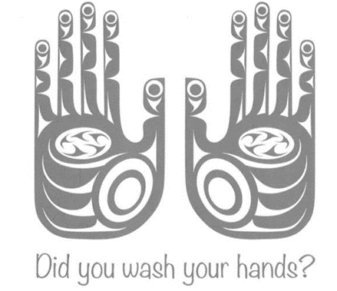  Key Info  - For assessment and supports:  www.abbotsfordcovidresponse.com  - Use Phone/Online Consult at Your Doctor and Pharmacist  - Senior/vulnerable people store hours 8am- 9am at Saveon, Superstore No Frills, and Shoppers  News Sources  Please get your info from trusted news sources, such as:  - The BC Centre for Disease Control  - First Nations Health Authority  - The Government of Canada/ Indigenous Services Canada  - BC Health Ministry  - Fraser Health Authority  SFN will continually update social media, website, and bulletins.  BAND SERVICES  Members-only/ closed to public:  BY APPOINTMENT ONLY  Front doors will be locked as precaution, please call on arrival  Health & Admin Buildings:  Call reception @ 604-852-4041  Monday- Friday 8am – 4pm  Smoke Shop:  Thursday- Friday 1 – 3pm  SCHEDULED EVENTS  March 19th Youth Group  March 20th Soup Kitchen  All other events & appt’s cancelled until further notice  FOOD PARCELS  Food parcels going to members on-reserve March 20-21.  Info on additional food parcels to come in following weeks.  By providing these necessity items, we wish to better enable members to stay at home and not travel unless essential.


