Corona Virus (Covid19) Bulletin | - April 1, 2020  - •  - Sumas First Nation
Local Health Updates: Mon, Weds, Fri @ 8pm on Sto:lo Nation Facebook with Inez Louis  COVID-19 presents a danger to our community’s health and wellbeing— it is up to each of us to act responsibly. Let’s Emo:t. One Heart, One Mind.  Advisory  Chief and Council request that ALL members exercise caution. Please only take trips to purchase essential items. While outside of your home, use social distancing and hygiene protocols.  We must all do our part to stop the spread of germs to our vulnerable members, such as Elders, children and those with respiratory conditions.  Key Info  - Covid Assessment:  www.abbotsfordcovidresponse.com  - Marshall Pharmacy Delivery: 604-859-8333  - Education Support with Keep Learning BC:  www.openschool.bc.ca  - Senior/Vulnerable Store: Hours 8am- 9am at Saveon, Superstore No Frills, and Shoppers  Community Update  Mar 25th support cheques sent to off-reserve members  Smoke Shop Open April 3 & 9 1-3pm  Emergency Plan Team  Wendy Phair, General Manager  778-347-3705  Wendy.phair@sumasfirstnation.com  Jackie Bird, Health/Wellness Manager  604-751-0961 Jackie.bird@sumasfirstnation.com  Craig Hougen, Director SXDL 604-226-9669  Craig.hougen@sumasfirstnation.com  Lori Kelly, Executive Assistant 778-908-9092  Lori.kelly@sumasfirstnation.com  Joe Silver, Public Works 604-751-0954  Joe.silver@sumasfirstnation.com  Emily Slater, Communications Officer 672-998-3056 Emily.slater@sumasfirstnation.com  Jonathan Swanson, Governance Manager 778-808-9250  Jonathan.swanson@sumasfirstnation.com  Geshia Flores, DC/PS Manager 778-246-5245  Geshia.flores@sumasfirstnation.com  Call Line Outreach  Josie Kelly, Lands Officer 604-751-5614  Josie.kelly@sumasfirstnation.com  Malonie Langthorne, Employment 604-807-1222  Malonie.langthorne@sumasfirstnation.com  Jennette Pierre, EDO SXDL  604-315-3264 Jennette.pierre@sumasfirstnation.com  Lyndy Silver, Executive Assistant SXDL  Lyndy.silver@sumasfirstnation.com  Food Security  Amber Ned, Education Coordinator 778-918-2840 Amber.ned@sumasfirstnation.com  Alana James, Events Coordinator 604-226-1582 Alana.james@sumasfirstnation.com  Barb Kelly, Youth & Cultural Worker 604-226-6051  Barb.kelly@sumasfirstnation.com  Background Info  COVID-19 is a new disease that has not been previously identified in humans.  Consult your health care provider ASAP if:  You display symptoms and/or  You traveled to a high-risk region  Prevention  ➊ Practice vigilant hand washing  ➋ Avoid touching your face  ➌ Work from home if possible  ➍ Comply with travel advisories & self-isolation  ➎ Maintain social distancing of six feet  Symptoms  Fever, Cough, Difficulty Breathing & Pneumonia  If you are ill and must visit a health care professional, call ahead or arrange a phone/video consult.  Diagnosis  Coronavirus infections are diagnosed by a health care provider based on symptoms and lab tests.  Treatment (flu vaccine will not protect you)  There is no vaccine or natural health products authorized for COVID-19 treatment.  Most people with mild coronavirus illness will recover on their own. Your health care provider may recommend steps you can take for symptom relief.  Please get your news from:  - The BC Centre for Disease Control  - First Nations Health Authority  - Fraser Health  - The Government of Canada  - The Government of BC  - Assembly of First Nations  - SFN Social Media & Website | BAND SERVICES  Health & Admin Buildings:  Call Reception @ 604-852-4041  Monday- Friday 8am – 4pm  Members-Only by Appointment  All Other Services:  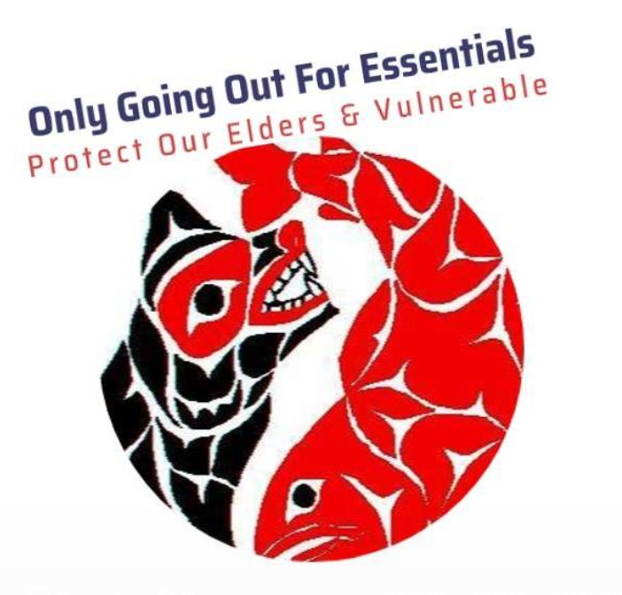  Closed until further notice  Leadership Contacts  Dalton Silver, Chief 604-751-0947  Dalton.silver@sumasfirstnation.com  Clint Tuttle, Council Rep 604-751-0967  Clnt.tuttle@sumasfirstnation.com  Murrary Ned, Councillor 604-309-7824  Murrary.ned@sumasfirstnation.com  Chris Silver, Councillor 778-347-3707  Chris.silver@sumasfirstnation.com

